Fig1 shows the the relationship between S1_IgG level and the key feature in the blood test samples of patients around the time of admission. Fig2 shows The relationship between S1_IgG level and the key feature in the blood test samples of patients around the timee of admission.

It easy to find that the relationship of S1_IgG level and the key features between the time after admission and the time of discharge (or death) is not obviously changed.

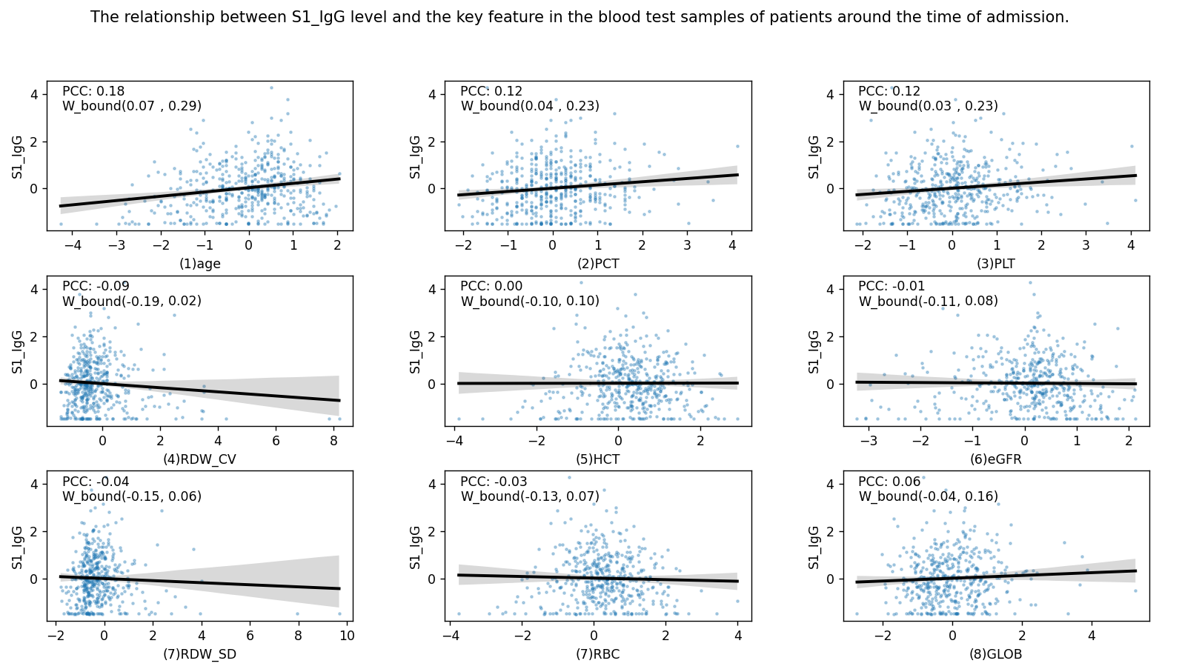

Fig. 1: The relationship between S1_IgG level and the key feature in the blood test samples of patients around the time of admission

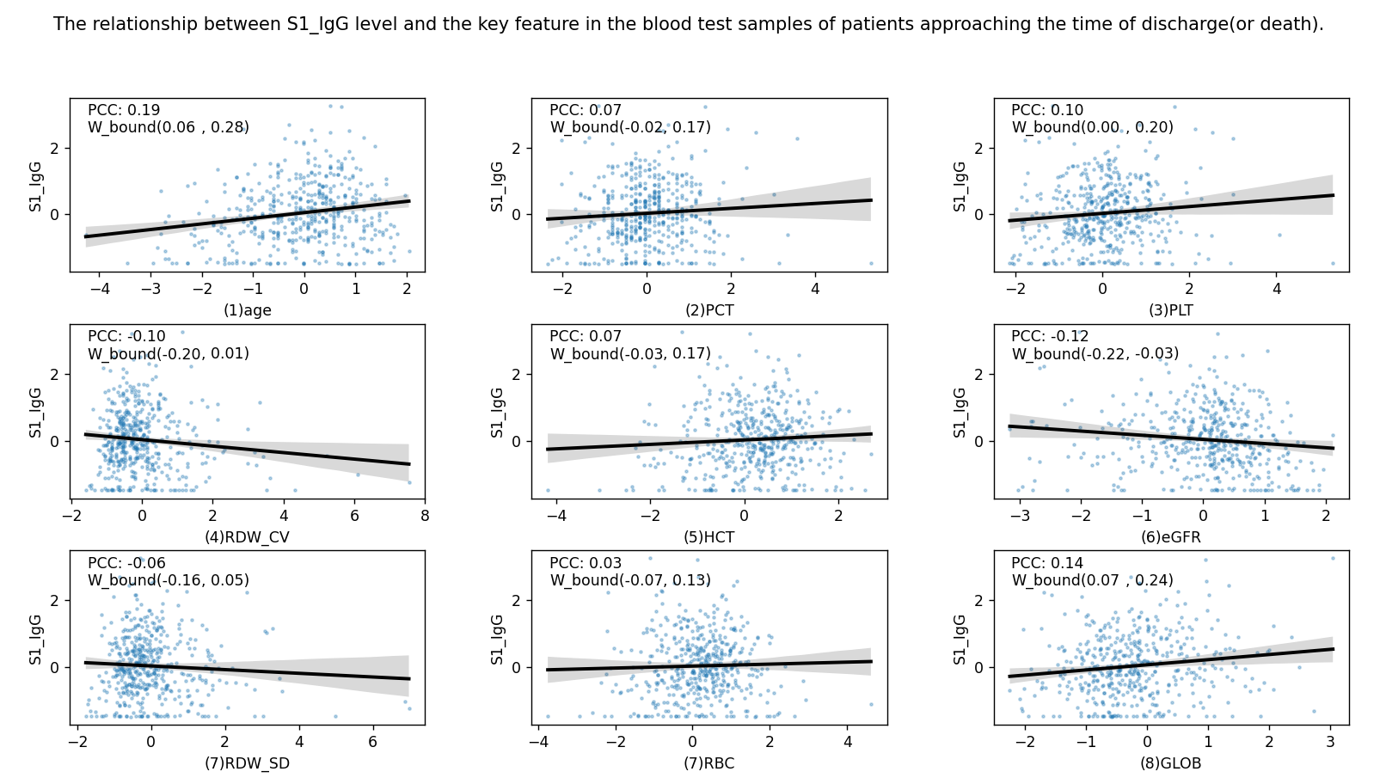

Fig2: The relationship between S1_IgG level and the key feature in the blood test samples of patients around the time of admission